Esercitazione 7.

Simulare la seguente rete e rendi possibile la comunicazione tra tutte le sottoreti presenti, compila la tabella sottostante (modifica spazi ,righe, colonne se necessario) ed etichetta tutti i dispositivi.

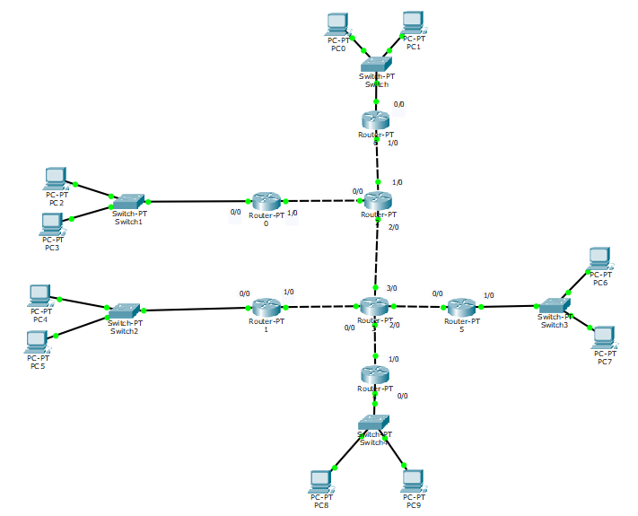

|  |  |  |
| --- | --- | --- |
| **Router** | **Interfaccia** | **IP Address** |
| Router 0 | Fa 0/0  Fa 1/0 | 192.168.11.1  192.168.0.11 |
| Router 1 | Fa 0/0  Fa 1/0 | 192.168.12.1  192.168.3.11 |
| Router 2 | Fa 0/0  Fa 1/0 | 192.168.0.10  192.168.1.10 |
| Router 3 | Fa 0/0  Fa 1/0  Fa 2/0  Fa 3/0 | 192.168.3.10  192.168.4.10  192.168.5.10  192.168.2.11 |
| Router 4 | Fa 0/0  Fa 1/0 | 192.168.14.1  192.168.4.11 |
| Router 5 | Fa 0/0  Fa 1/0 | 192.168.5.11  192.168.13.1 |
| Router 6 | Fa 0/0  Fa 1/0 | 192.168.10.1  192.168.1.11 |

|  |  |  |
| --- | --- | --- |
| **PC** | **IP Address** | **Gateway** |
| PC0 | 192.168.10.2 | 192.168.10.1 |
| PC1 | 192.168.10.3 | 192.168.10.1 |
| PC2 | 192.168.11.2 | 192.168.11.1 |
| PC3 | 192.168.11.3 | 192.168.11.1 |
| PC4 | 192.168.12.3 | 192.168.12.1 |
| PC5 | 192.168.12.2 | 192.168.12.1 |
| PC6 | 192.168.13.2 | 192.168.13.1 |
| PC7 | 192.168.13.3 | 192.168.13.1 |
| PC8 | 192.168.14.2 | 192.168.14.1 |
| PC9 | 192.168.14.3 | 192.168.14.1 |